Lab 03: Encapsulation, Data Validation, Immutability and Information Hiding.
Exercise 1: Creating a Car Class
Student Name: Jichichi Clive T
Registration Number: H250254B
Programme: Software Engineering
Date: 8/10/2026
Exercise 1
Exercise 1: Student Class with Validated Marks
Aim: To demonstrate encapsulation and data validation in Java.
Source Code
Student.java
package lab03encapsulation;

// Represents a student and protects their information
public class Student {

// Private fields prevent direct access from other classes
private String name;
private int marks;

// Constructor initializes the student's name and marks
public Student(String name, int marks) {
setName(name);
setMarks(marks);
}

// Returns the student's name
public String getName() {
return name;
}

// Updates the name after checking that it is valid
public void setName(String name) {
if (name == null || name.trim().isEmpty()) {
throw new IllegalArgumentException(
"Name cannot be empty.");
}

this.name = name;
}

// Returns the student's marks
public int getMarks() {
return marks;
}

// Accepts only marks from 0 to 100
public void setMarks(int marks) {
if (marks < 0 || marks > 100) {
throw new IllegalArgumentException(
"Marks must be between 0 and 100.");
}

this.marks = marks;
}
}
Main.java
package lab03encapsulation;

// Tests the Student class and its validation
public class Main {

public static void main(String[] args) {

// Creates a student with valid marks
Student student = new Student("Tendai", 85);

// Displays the student's information
System.out.println("Name: " + student.getName());
System.out.println("Marks: " + student.getMarks());

// Attempts to assign invalid marks
try {
student.setMarks(120);
} catch (IllegalArgumentException e) {
System.out.println("Validation error: "
+ e.getMessage());
}

// Confirms that the original marks remain unchanged
System.out.println("Marks after invalid update: "
+ student.getMarks());
}
}
Output
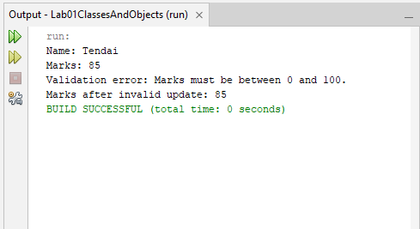
Explanation: The name and marks fields are private and accessed through public methods. The setMarks() method rejects values below 0 or above 100 by throwing an exception.
Conclusion: The exercise demonstrated how encapsulation and validation protect an object's data from invalid updates.

Exercise 2: Calculating Student Grades
Aim: To implement a method that calculates a student's grade from their marks.
Source Code
Student.java
package lab03encapsulation;

// Represents a student and protects their information
public class Student {

// Private fields store the student's name and marks
private String name;
private int marks;

// Constructor initializes the student's details
public Student(String name, int marks) {
setName(name);
setMarks(marks);
}

// Returns the student's name
public String getName() {
return name;
}

// Validates and updates the student's name
public void setName(String name) {
if (name == null || name.trim().isEmpty()) {
throw new IllegalArgumentException(
"Name cannot be empty.");
}

this.name = name;
}

// Returns the student's marks
public int getMarks() {
return marks;
}

// Accepts only marks between 0 and 100
public void setMarks(int marks) {
if (marks < 0 || marks > 100) {
throw new IllegalArgumentException(
"Marks must be between 0 and 100.");
}

this.marks = marks;
}

// Calculates the grade from the current marks
public char getGrade() {
if (marks >= 80) {
return 'A';
} else if (marks >= 70) {
return 'B';
} else if (marks >= 60) {
return 'C';
} else {
return 'F';
}
}
}
Main.java

package lab03encapsulation;

// Tests student marks and grade calculation
public class Main {

public static void main(String[] args) {

// Creates students with different marks
Student student1 = new Student("Tendai", 85);
Student student2 = new Student("Rudo", 75);
Student student3 = new Student("Tariro", 65);
Student student4 = new Student("Kuda", 45);

// Displays each student's marks and calculated grade
System.out.println(student1.getName() + ": "
+ student1.getMarks() + " - Grade "
+ student1.getGrade());

System.out.println(student2.getName() + ": "
+ student2.getMarks() + " - Grade "
+ student2.getGrade());

System.out.println(student3.getName() + ": "
+ student3.getMarks() + " - Grade "
+ student3.getGrade());

System.out.println(student4.getName() + ": "
+ student4.getMarks() + " - Grade "
+ student4.getGrade());
}
}
Output
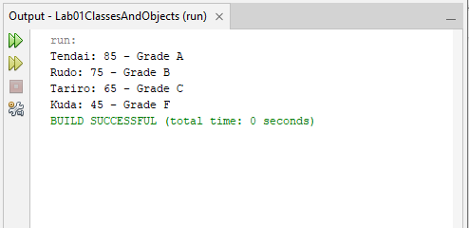
Explanation: The getGrade() method uses conditional statements to return A, B, C, or F according to the student's marks. The grade is calculated when requested and is not stored in a separate field.
Conclusion: The exercise demonstrated how methods can derive information from existing object data without storing unnecessary fields.

Exercise 3: Bank Account Transaction History
Aim: To maintain transaction records while protecting the internal list from external modification.
Source Code
BankAccount.java

package lab03encapsulation;

import java.util.ArrayList;
import java.util.Collections;
import java.util.List;

// Represents a bank account with transaction history
public class BankAccount {

// Stores the current account balance
private double balance;

// Stores transaction descriptions privately
private final List<String> transactions = new ArrayList<>();

// Constructor initializes the account balance
public BankAccount(double initialBalance) {
if (initialBalance < 0) {
throw new IllegalArgumentException(
"Initial balance cannot be negative.");
}

balance = initialBalance;
transactions.add("Account opened with balance: "
+ initialBalance);
}

// Returns the current balance
public double getBalance() {
return balance;
}

// Deposits money and records the transaction
public void deposit(double amount) {
if (amount <= 0) {
throw new IllegalArgumentException(
"Deposit must be greater than zero.");
}

balance += amount;
transactions.add("Deposited: " + amount);
}

// Withdraws money if sufficient funds are available
public void withdraw(double amount) {
if (amount <= 0) {
throw new IllegalArgumentException(
"Withdrawal must be greater than zero.");
}

if (amount > balance) {
throw new IllegalArgumentException(
"Insufficient funds.");
}

balance -= amount;
transactions.add("Withdrew: " + amount);
}

// Returns an unmodifiable copy of the transaction history
public List<String> getTransactions() {
return Collections.unmodifiableList(
new ArrayList<>(transactions));
}
}
Main.java

package lab03encapsulation;

import java.util.List;

// Tests bank account transactions and history protection
public class Main {

public static void main(String[] args) {

// Creates a bank account with an initial balance
BankAccount account = new BankAccount(500.0);

// Performs two transactions
account.deposit(200.0);
account.withdraw(100.0);

// Displays the current balance
System.out.println("Current balance: "
+ account.getBalance());

// Retrieves and displays transaction history
List<String> history = account.getTransactions();

System.out.println("Transaction History:");
for (String transaction : history) {
System.out.println(transaction);
}

// Attempts to modify the returned transaction list
try {
history.add("Fake transaction");
} catch (UnsupportedOperationException e) {
System.out.println(
"Transaction history cannot be modified.");
}
}
}
Output
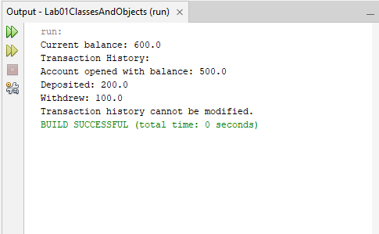
Explanation: The BankAccount class stores transactions in a private list. The getTransactions() method returns an unmodifiable copy, preventing callers from changing the returned list or the account's original transaction history.
Conclusion: The exercise demonstrated encapsulation and defensive copying to protect an object's internal data.

Exercise 4: ImmutablePerson
Aim: To create an immutable Java class whose information cannot be changed after the object is created.
Source Code
Immutable.java

package lab03encapsulation;

// final prevents other classes from extending this class
public final class ImmutablePerson {

// private prevents direct access; final prevents reassignment
private final String name;
private final int age;

// Constructor sets the values when the object is created
public ImmutablePerson(String name, int age) {

if (name == null || name.trim().isEmpty()) {
throw new IllegalArgumentException(
"Name cannot be empty.");
}

if (age < 0) {
throw new IllegalArgumentException(
"Age cannot be negative.");
}

this.name = name;
this.age = age;
}

// Getters allow read-only access to the fields
public String getName() {
return name;
}

public int getAge() {
return age;
}
}
Main.java

package lab03encapsulation;

// Tests the immutable person class
public class Main {

public static void main(String[] args) {

// Creates a person with fixed information
ImmutablePerson person =
new ImmutablePerson("Tendai", 21);

// Displays the person's information
System.out.println("Name: " + person.getName());
System.out.println("Age: " + person.getAge());

// No setters are provided to change these values
System.out.println(
"Person information cannot be changed "
+ "through setters.");
}
}
Output
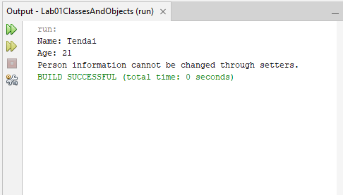
Explanation:
- final class: Prevents other classes from extending ImmutablePerson.
- private fields: Prevent direct access to the object's data.
- final fields: Ensure that the fields are assigned only once.
- No setters: Prevent changing the person's name and age through setter methods.
- Constructor validation: Prevents empty names and negative ages.
- Getters: Allow users to read the information without modifying it.
Conclusion: The exercise demonstrates immutability and encapsulation by protecting an object's data after initialization.
Exercise 5: Temperature Class
Aim: To create a temperature class that stores values in Kelvin, converts them to Celsius and Fahrenheit, and rejects invalid temperatures.
Source Code
Temperature.java

package lab03encapsulation;

// Represents temperature using Kelvin internally
public class Temperature {

// Private field prevents direct access to the stored value
private final double kelvin;

// Constructor validates the temperature
public Temperature(double kelvin) {

if (Double.isNaN(kelvin)
|| Double.isInfinite(kelvin)
|| kelvin < 0) {
throw new IllegalArgumentException(
"Temperature cannot be below absolute zero.");
}

this.kelvin = kelvin;
}

// Converts Kelvin to Celsius
public double getCelsius() {
return kelvin - 273.15;
}

// Converts Kelvin to Fahrenheit
public double getFahrenheit() {
return (kelvin - 273.15) * 9.0 / 5.0 + 32;
}
}
Main.java

package lab03encapsulation;

// Tests temperature conversion and validation
public class Main {

public static void main(String[] args) {

// Creates a temperature of 300 Kelvin
Temperature temperature = new Temperature(300.0);

// Uses public methods instead of accessing internal storage
System.out.printf("Celsius: %.2f °C%n",
temperature.getCelsius());

System.out.printf("Fahrenheit: %.2f °F%n",
temperature.getFahrenheit());

// Tests rejection of a temperature below absolute zero
try {
Temperature invalid = new Temperature(-5.0);
} catch (IllegalArgumentException e) {
System.out.println(
"Invalid temperature rejected: "
+ e.getMessage());
}

// The caller depends on the public methods, not the field
System.out.println(
"Temperature conversions use the public API.");
}
}
Output
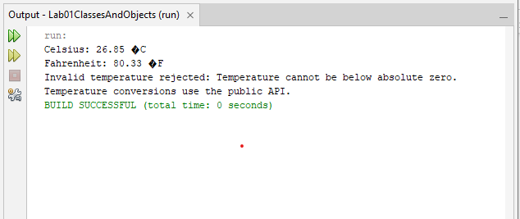
Explanation:
- Encapsulation: The kelvin field is private, preventing direct access from outside the class.
- Validation: The constructor rejects negative Kelvin values, as well as invalid numeric values.
- Conversion methods: getCelsius() and getFahrenheit() convert the stored Kelvin value into the required units.
- Stable public interface: Other classes use the public conversion methods instead of accessing the internal field. The internal storage unit could therefore be changed while keeping these methods unchanged, provided their conversion logic is updated accordingly.
Conclusion: The exercise demonstrates encapsulation, input validation, temperature conversion, and abstraction through a stable public interface.

